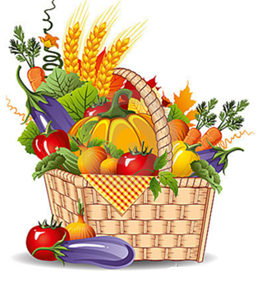
We hope that you will be able to join us at this year’s Harvest Fair as it is a great opportunity to raise awareness of your business and to make new friends in the area.

We are working to make a successful community event and experience for all. To that end, we ask that you carefully review the stall holders instructions. Details on how to reserve you space can be found below.

The Committee has established that stall holders must adhere to a harvest or eco related theme. Our fair celebrates, first and foremost, local products and crafts and things related to sustainability.

Stall hire is £20 for a single or £30 for a double space and includes tables and chairs. Stall holders are to provide their own tents. Please inform us if you are using a tent and its size? We don’t provide electricity.

There is no smoking on church property. We thank all stall holders for respecting this policy.

We ask stall holders not to bring pets to the church either at set-up or during the fair.

Stall holders are responsible for their own set up and take down. Please bring your own helpers to unload or load your vehicles. Stall holders must remove all unsold items from the church on Saturday at the end of the Fair. Please leave your area as clean as you found it. This includes bagging and removing your rubbish.

Stall holders are responsible for insuring their own stall, the event has its own public liability insurance.

Set-up is on Saturday, 2nd October between 7-9am. Please be ready for the public by 9.30am.
Please do not start to break down your display until 2pm.

The Harvest Fair is a RAIN or SHINE event as such, please be prepared for inclement weather.

COVID Safety Measures. Please make sure you have hand sanitiser available at each stall. Scottish government guidelines applicable on the day for outdoor events will be adhered to.

We make every effort to advertise the Harvest Fair. You have the opportunity to do the same, by letting your customer base and friends know about this event. An event will be created on Facebook and we will send you a link on reservation to share with your customers. The more we advertise, the more you are assured of a profitable event.

Understandably, the wear and tear on our historic property from a community event of this natures is a concern. We request your help, as a stall holder, to maintain your booth space and respect our sacred spaces and property.

All stall holders must complete a reservation form. Forms should be sent to the email address events.stlandm@gmail.com. On receipt of the form payment details will be sent via email and the process will be confirmed as complete on receipt of payment.

